Project Design Phase-II

Data Flow Diagram & User Stories

03 October 2022

PNT2022TMID20096

Project - xxx

|  |  |
| --- | --- |
| Date | 03 October 2022 |
| Team ID | PNT2022TMID31937 |
| Project Name | Project – Retail Store Stock Inventory Analysis |
| Maximum Marks | 4 Marks |

# Data Flow Diagrams:

A Data Flow Diagram (DFD) is a traditional visual representation of the information flows within a system. A neat and clear DFD can depict the right amount of the system requirement graphically. It shows how data enters and leaves the system, what changes the information, and where data is stored.

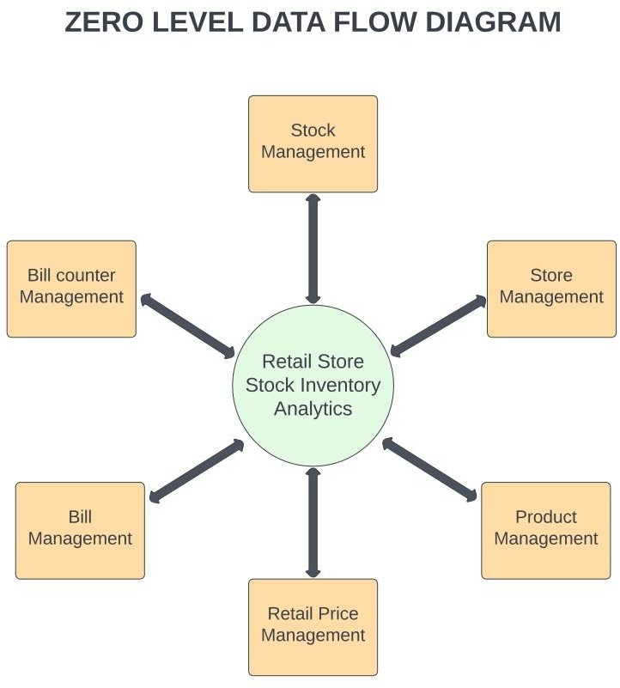

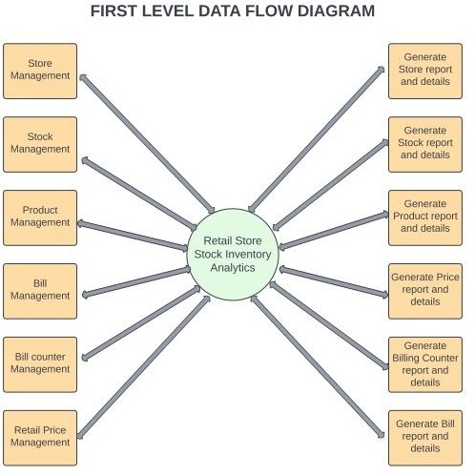

# User Stories

Use the below template to list all the user stories for the product.

|  |  |  |  |  |  |  |
| --- | --- | --- | --- | --- | --- | --- |
| **User Type** | **Functional**  **Requirement (Epic)** | **User Story Number** | **User Story / Task** | **Acceptance criteria** | **Priority** | **Release** |
| Customer (Mobile user) | Registration | USN-1 | As a user, I can register for the application by entering my email, password, and confirming my password. | I can access my account / dashboard | High | Sprint-1 |
|  |  | USN-2 | As a user, after completing the registration I will  receive confirmation email once I have registered for the web application | I can receive  confirmation email & click confirm | High | Sprint-1 |
|  |  | USN-3 | As a user, I can register for the application  through Facebook | I can register & access the  dashboard with Facebook Login | Low | Sprint-2 |
|  |  | USN-4 | As a user, I can register for the application through Gmail | I can register & access the dashboard with Gmail  login | Medium | Sprint-1 |
|  | Login | USN-5 | As a user, I can log into the application by entering email & password after installing the web application. | I can access the dashboard by login into the application | High | Sprint-1 |
|  | Dashboard | USN-6 | As a user, I can view the charts and graphs representation of the dataset and the information shown in the dashboard. | I can analyse the stocks in my retail store. | High | Sprint-1 |
| Customer (Web user) |  | USN-1 | As a user, I can register for the web application entering my email, password and confirming my password. | I can access my account dashboard | High | Sprint-1 |
|  |  | USN-2 | As a user, after completing the registration I will  receive confirmation email once I have registered  for the web application | I can receive confirmation  email & click confirm | High | Sprint-1 |
| Administrator |  | USN-3 | As a user, I can register for the application through Facebook | I can register & access the dashboard with Facebook Login | Low | Sprint-2 |

|  |  |  |  |  |  |  |
| --- | --- | --- | --- | --- | --- | --- |
|  |  | USN-4 | As a user, I can register for the application through Gmail | I can register & access the dashboard with Gmail  login | Medium | Sprint-1 |

|  |  |  |  |  |  |  |
| --- | --- | --- | --- | --- | --- | --- |
| **User Type** | **Functional Requirement (Epic)** | **User Story Number** | **User Story / Task** | **Acceptance criteria** | **Priority** | **Release** |
|  | Login | USN-5 | As a user, I can log into the application by entering  email & password after installing the web application. | I can access the dashboard by login into the application | High | Sprint-1 |
|  | Dashboard | USN-6 | As a user, I can view the charts and graphs representation of the dataset and the  information shown in the dashboard. | I can analyse the stocks in my retail store | High | Sprint-1 |
| Customer Care Executive |  | CCE-1 | As a customer care executive, I will always be available for the interaction with the customer to clarify the queries. | An executive will analyse the customer complaints and rectify their problems. | High | Sprint-2 |
| Administrator |  | ADMIN-1 | As an administrator, I will manage backup and recovery, data modelling and design, distributed computing, database system, and a data security | Administrator can evaluate, design, review and implementing a data and they are also responsible for updating and maintaining the data | HIgh | Sprint-2 |